TMC Computing Limited

Health and Safety Policy
TMC Computing Limited considers health and safety to be of utmost importance. We comply with The Health and Safety at Work Act 1974 and the Workplace (Health, Safety and Welfare) Regulations 1992 at all times.
The Club has appropriate insurance cover, including employer’s liability insurance and public liability insurance.
Each member of staff follows the Club’s Health and Safety policy and is responsible for:
- Maintaining a safe environment
- Taking reasonable care for the health and safety of themselves and others attending the Club
- Reporting all accidents and incidents which have caused injury or damage or may do so in the future
- Undertaking relevant health and safety training when required to do so by the manager.
Any member of staff who disregards safety instructions or recognised safe practices will be subject to disciplinary procedures.
Responsibilities of the registered person
The registered person for the setting holds ultimate responsibility and liability for the safe operation of the Club. The registered person will ensure that:
- They nominate a Health and Safety Officer. Each individual setting may have a different Health & Safety Officer based on which staff are based there.
- All staff receive information on health and safety matters and receive training where necessary
- The Health and Safety policy and procedures are reviewed regularly
- Staff understand and follow health and safety procedures
- Resources are provided to meet the Club’s health and safety responsibilities including evacuation, fire detection and control and suitable resourcing.
- All accidents, incidents and dangerous occurrences are properly reported and recorded. This includes informing Ofsted, child protection agencies and the Health and Safety Executive under RIDDOR (Reporting of Injuries, Diseases and Dangerous Occurrences Regulations 1995) where appropriate.
- All reported accidents, incidents and dangerous occurrences are reviewed, so that preventative measures can be taken.
Responsibilities of the Club Leader
The Club’s Leader is responsible for ensuring that at each session:
- Premises are clean, well lit, adequately ventilated and maintained at an appropriate temperature
- The premises are used by and solely available to the Club during opening hours
- All the Club’s equipment is safely and securely stored
- A phone is available on the premises at all times
- Chemicals and cleaning materials are stored appropriately, and in accordance with COSHH data sheets.
Security
During Club sessions all external doors are kept locked, with the exception of fire doors which are alarmed. Staff monitor the entrances and exits to the premises throughout the session.
Security procedures will be regularly reviewed by the club leader with the Director, in consultation with staff and parents.
Equipment
All equipment is kept clean, well maintained and in good repair. We select equipment and resources with care and we carry out risk assessments before the children are allowed to use them. Broken equipment is disposed of promptly.
We ensure that any flammable equipment is stored safely. We do not use chargers, pluggable items etc however if the need arises, our equipment is PAT Tested.
Dealing with body fluids
Spillages of blood, vomit, urine and faeces will be reported immediately to staff and cleaned promptly.
Staffing levels
Staff ratios and levels of supervision are always appropriate to the number, ages and abilities of the children present and to the risks associated with the activities being undertaken.
Related policies
See also our related policies: Illness and Accidents, Emergency Evacuation, Healthy Eating, Safeguarding, Administering Medication, Risk Assessment, Manual Handling, Fire Safety and Intimate Care, Visitor – These can all be found on our website at www.tmccomputing.com

This policy was adopted by: TMC Computing Limited - Version Number 2. | Date: 02/06/2026
To be reviewed: 02/06/2027 | Signed: Toni-Marie McCarrick
Written in accordance with the Statutory Framework for the Early Years Foundation Stage (2025): Safeguarding and Welfare Requirements: Safety and suitability of premises, environment and equipment [3.77 – 3.86]

HEALTH & SAFETY POLICY ACKNOWLEDGEMENT
I confirm that I have received, read and understood the Health & Safety Policy 2026.
I understand my responsibilities under the policy and agree to follow all health and safety procedures, including risk assessments, fire safety arrangements, accident reporting procedures, safeguarding requirements, emergency procedures and any other measures implemented to protect children, staff and visitors.
I understand that if I am unsure about any aspect of the policy, I must seek clarification from Club Leaders or Directors.
Staff Name (Print) | Position | Signature | Date
Ryan Eagers | Club Leader
Juliet Edmonds | Club Assistant
Summer Spriggs | Club Assistant | 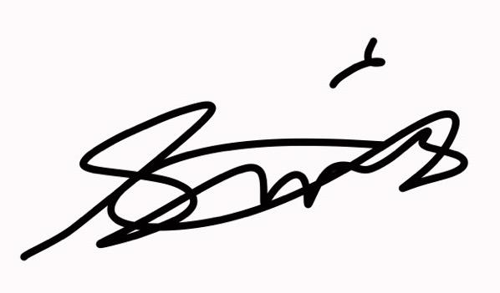 | 25/06/26
Vanessa Johnson | Club Assistant

Director Signature:
Director Name: Toni-Marie McCarrick

