TMC Computing Limited

Fire Safety and Fire Risk Assessment
TMC Computing Limited understands the importance of fire safety. To this end:
- Staff are aware of the location of all fire exits, the fire assembly point and where fire safety equipment is stored.
- Children are introduced to the fire safety procedures during their settling in period and through regular fire drills at the school.
- Fire drills are conducted regularly during school hours so children are aware of the procedure.
- All children are shown the location of fire exits and the fire assembly point.
- Fire doors and fire exits are clearly marked, are not obstructed at any time and are easily opened from the inside.
- Fire doors are kept closed at all times but never locked.
Fire prevention
The Club will take all steps possible to prevent fires occurring by:
- Ensuring that power points are not overloaded with adaptors or just avoiding user power altogether.
- Ensuring that the Club’s No Smoking policy is always observed.
- Reporting frayed or trailing wires to the staff promptly, if noticed whilst using the facilities.
- Storing any potentially flammable materials safely.
- Devices are PAT tested, either by the organisation of the school or TMC Computing Limited.
In the event of a fire
- A member of staff will raise the alarm and call the emergency services.
- The children will immediately be escorted out of the building to the assembly point using the nearest marked exit.
- No attempt will be made to collect personal belongings, or to re-enter the building after evacuation.
- The premises will be checked by the Fire Safety Officer and the register will be collected, providing that it is safe to do so.
- The Fire Safety Officer in the school/setting will close all doors and windows to prevent the spread of fire when they leave the building if it is safe to do so.
- The register will be taken and all children and staff accounted for.
- If anyone is missing from the register, the emergency services will be informed.
- If the register is not available the manager will use the emergency contacts list (which is kept using our booking system) to contact parents or carers. The school/site will also be provided with a list of attendees for support in contacting parents using their own system if needed.

Responsibilities of the Fire Safety Officer
The Club’s Designated Fire Safety Officer is Toni-Marie McCarrick. The Fire Safety Officer is responsible for carrying out the fire safety risk assessment and for ensuring that all staff are made aware of fire safety procedures during their Induction period.
The Regulatory Reform (Fire Safety) Order 2005 requires that a fire safety risk assessment is undertaken for the workplace based on The Department of Communities and Local Government’s 5 step guide: https://www.gov.uk/government/uploads/system/uploads/attachment_data/file/14899/fsra-5-step-checklist.pdf
The risk assessment should cover:
- Identifying potential fire risks
- Identifying people at risk
- Evaluating the risks arising from the hazards identified and the means of minimising those risks
- Recording the hazards, preparing a fire prevention plan and sharing these with other members of staff
- Reviewing the fire safety risk assessment on a regular basis.
The Fire Safety Officer should liaise with the local Fire and Rescue Service for further advice and should ensure that Emergency Contact details are recorded at the front of the register and a copy stored off premises.

This policy was adopted by: TMC Computing Limited | Date: 02/06/2026
To be reviewed: 02/06/2027 | Signed: Toni-Marie McCarrick

Written in accordance with the Statutory Framework for the Early Years Foundation Stage (2025): Safeguarding and Welfare Requirements: Safety and suitability of premises, environment and equipment [3.79, 3.80]

FIRE SAFETY POLICY ACKNOWLEDGEMENT
I confirm that I have received, read and understood the Fire Safety Policy 2026.
I understand my responsibilities under the policy and agree to follow all fire safety procedures and arrangements and any other measures implemented to protect children, staff and visitors.
I understand that if I am unsure about any aspect of the policy, I must seek clarification from Club Leaders or Directors.
Staff Name (Print) | Position | Signature | Date
Ryan Eagers | Club Leader
Juliet Edmonds | Club Assistant
Summer Spriggs | Club Assistant | 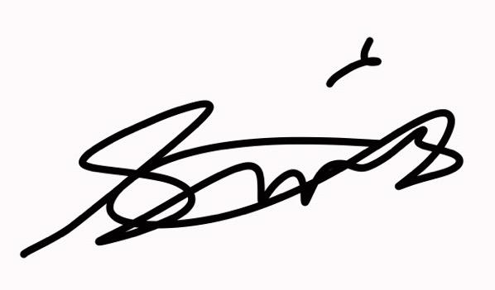 | 25/06/26
Vanessa Johnson | Club Assistant

Director Signature:
Director Name: Toni-Marie McCarrick

